# Homework 4 – DC Machines

*This homework is to be solved using computational tools (such as MATLAB). A template is provided. You should submit your homework by converting your .m file solution (from the template) to pdf by using publish command. Required explanations and several tips are given in the template*

## Q.1.

### Part A:

A 39-hp, 440V, Permanent Magnet Motor operates at 1000 rpm on full load. The motor efficiency is 86.72 %, and armature resistance is 0.337 ohm. (The motor is operating at steady state and the circuit schematic is illustrated at Figure 1.)

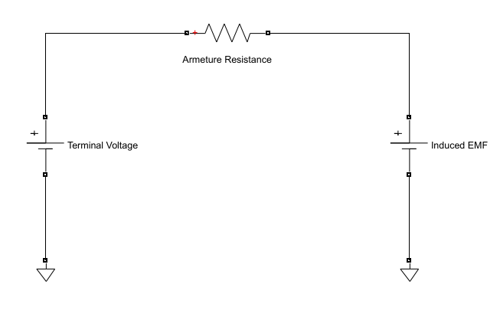

Figure 1 Simplified Circuit of PM DC Motor

1. Find the electrical power of the motor.
2. Find the armature current of the motor.
3. Find the induced EMF of the motor.
4. Find the mechanical power of the motor.
5. Find the mechanical torque of the motor.
6. Find the Rotational Loss and Armature Loss of the motor.
7. What do you suggest to control speed of the motor? Please, comment each suggestion properly.

### Part B:

The setup Figure 2 is established to make a speed control of DC motor and it is called that Ward-Leonard System.

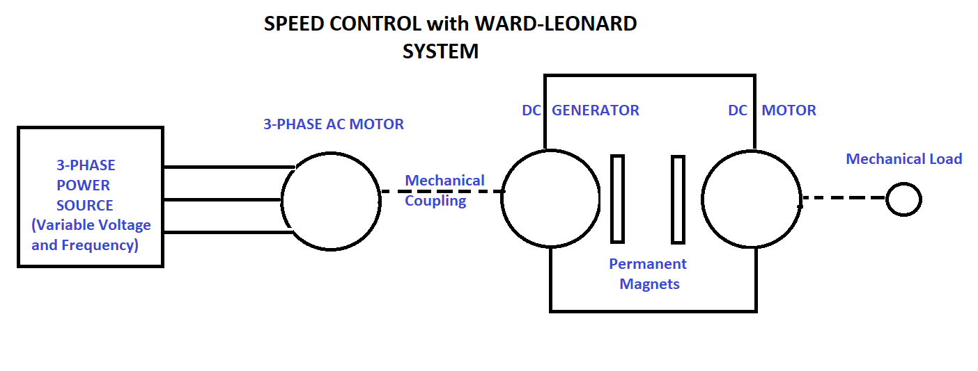

Figure 2 Ward-Leonard System

In short, DC motor are driven by the DC generator and The DC generator are rotated by 3-phase AC motor with mechanical coupling.

For the DC generator, armature resistance is 0.336 ohm. Assume that both motor and generator are operating in linear region, and rotational loss is constant. The Figure 3 shows circuit diagram of DC motor and the generator.

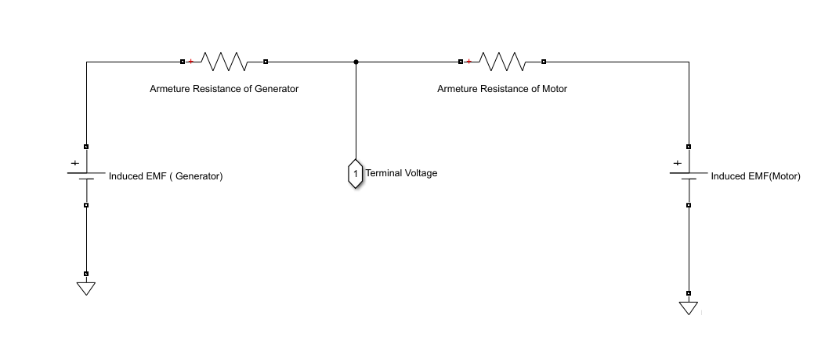

Figure 3 Simplified Circuit of connected Motor and Generator

1. Determine the induced emf of the generator at full load.
2. Determine the no-load speed of the motor. (The field circuits for generator and motor are the same)
3. If the DC generator is separately excited with constant field current. What must be the percentage of reduction in the field current of the generator to obtain no-load speed of 1025 rpm?
4. What must be the induced emf in the generator if the motor supplies the same torque as in Part A but at speed of 750 rpm?
5. What is the percent change in the field current of the generator?
6. What will the motor speed under no load?

## Q.2.

The reluctance motor is a synchronous motor whose reluctance changes as a function of angular displacement θ between the rotor and stator. The motor does not have field winding on the rotor, and single phase 2-pole reluctance motor is illustrated at Figure 4.

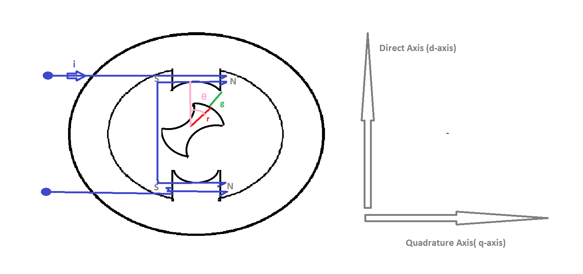

Figure 4 Single-Phase 2-Pole Reluctance Motor

When θ is zero, the effective air gap is minimum. So, reluctance is minimum and inductance is maximum. This inductance is called Ld.

When θ is 90 degree, the effective air gap is maximum. So, reluctance is maximum and inductance is minimum. This inductance is called Lq.

Assume that A is area per pole and A is constant for the every θ and permeability of gap is vacuum value. In addition, all reluctance of the magnetic circuit is in the gap.

L(θ) = 0.5(Ld+Lq) +0.5(Ld-Lq)*cos(2θ) Formula 1.

The formula 1 shows the change in inductance with respect to θ. The motor is excited by 100 turn-coil carries 2 A.

1. When θ is zero, effective air gap is 1 mm and A= 10 cm^2. Calculate reluctance and inductance.
2. When θ is 90-degree, effective air gap is 10mm and A=100mm^2. Calculate reluctance and inductance.
3. Plot inductance of the motor with respect to displacement angle.
4. Plot electrical torque of the motor with respect to displacement angle.
5. Assume that initial position(ẟ) of the motor is 30-degree and mechanical speed wm=377 rad/sec. Find the electrical torque. ( θ=t*wm + ẟ). What is the average torque?
6. If the excitation current is alternative current, how does electrical torque changes? Comment on the effect of source angular frequency, mechanical angular frequency and initial position on average torque.